Spring Boot and Microservices

Api

- Api is Application programming Interface.

- set of rules and protocols that allow one software application to interact and communicte with other.

- exmple :restaurant Menu

Why Api needs ?

- share data
- speed up devlopment

Popular Apis

- Google Maps Api
- Twitter Api

Types of API
-------------

- Internal API's eg) notifications api
- External api's eg) public api's
- partner Api's eg

Status Codes in APi
-------------------
req
client -------------> server
<-------------
res with status code

1xx (informational)
2xx (Successful)
3xx (Redirection)
4xx (client error)
5xx (srver Error)

Commonly used Status codes
---------------------------

-> 200 ok
-> 201 Created
-> 204 No Content ( nothing to return)
-> Moved Permanently
-> 400 Bad Request
-> 401 Unauthorized
-> 403 Forbidden
-> 404 Not Found
-> 500 Internal Server Error

Types of Api Request
_______________________

Get , Post , put , Delete

_______________________________________________________________________

Web FrameWork:
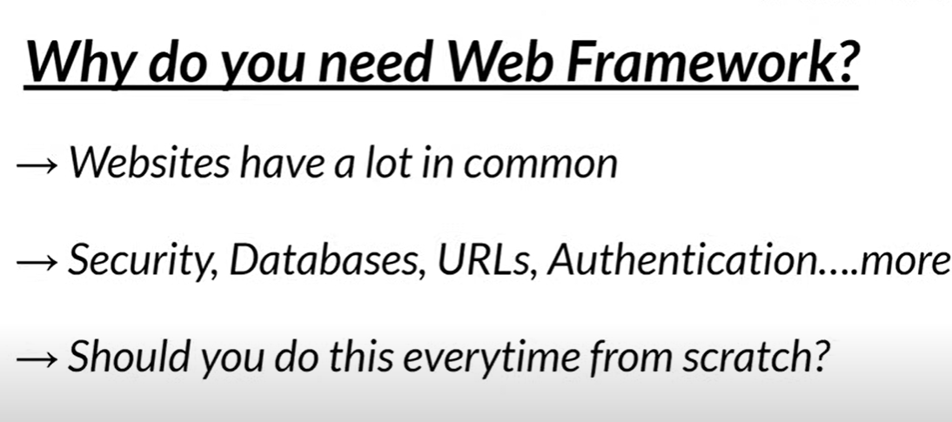
. >
k
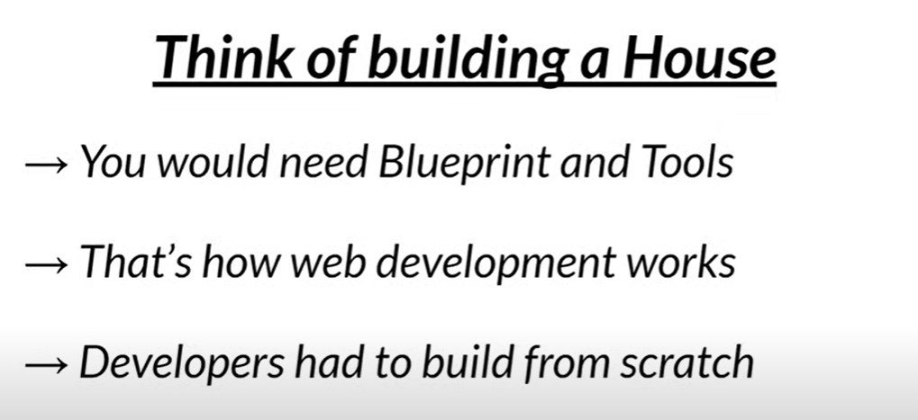
.
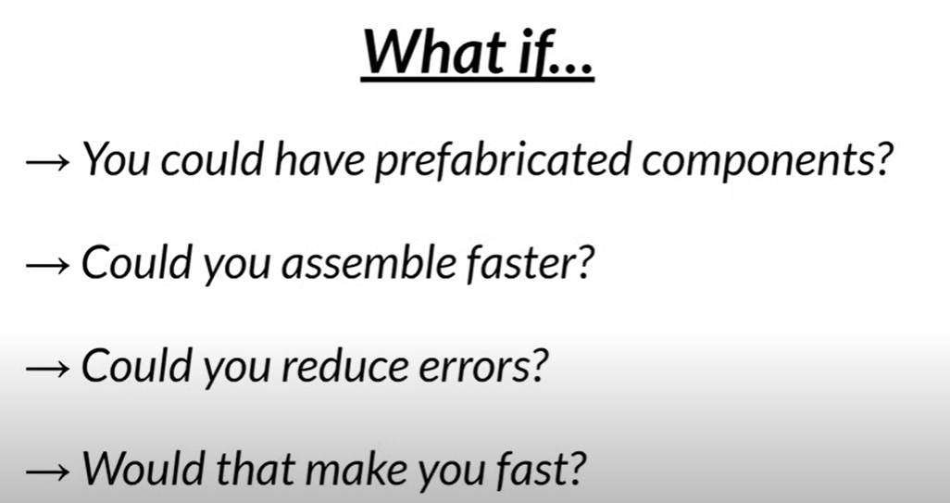
Fabricated means – thaiyaaripu

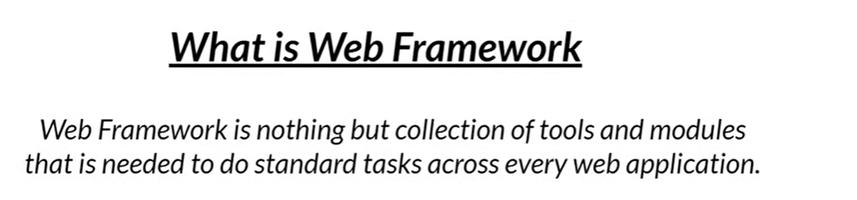
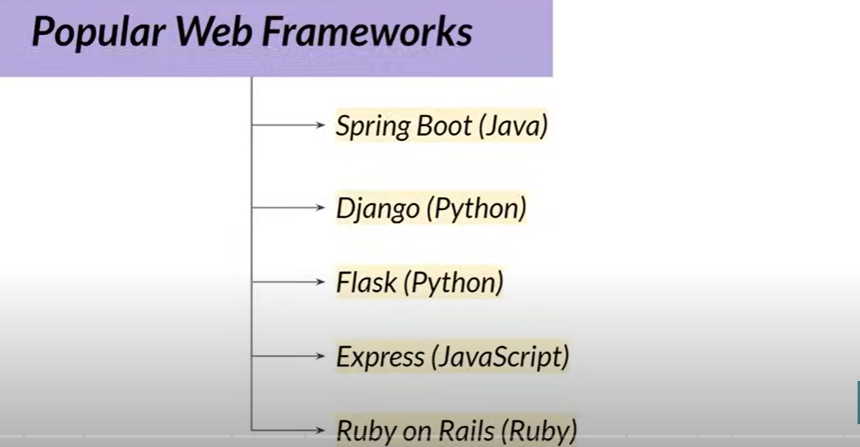
Spring

- Spring takes away the hassle
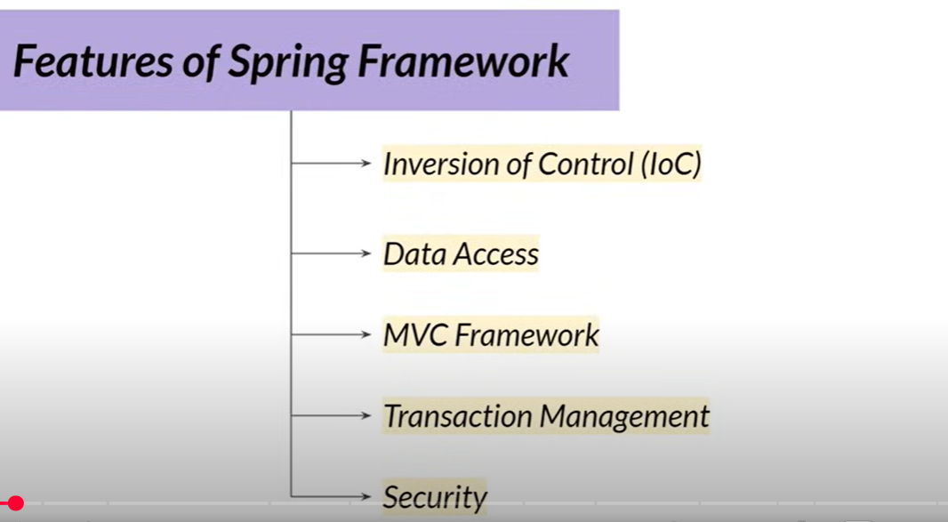
,
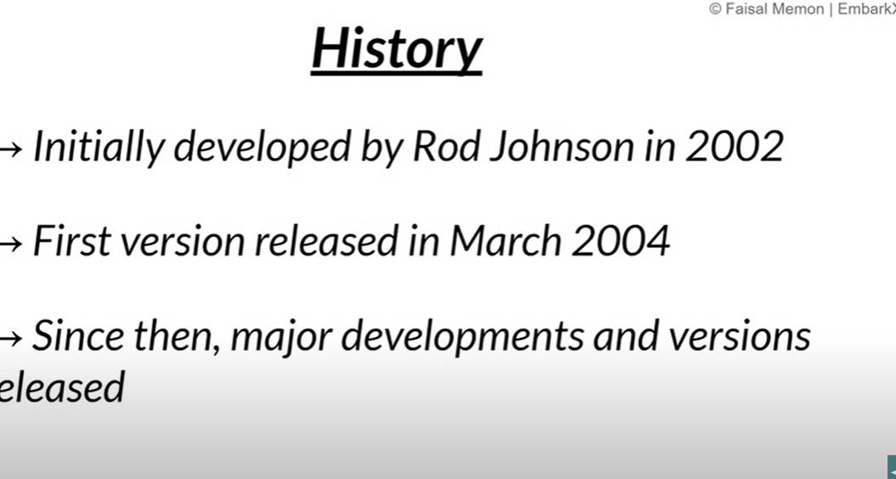
.
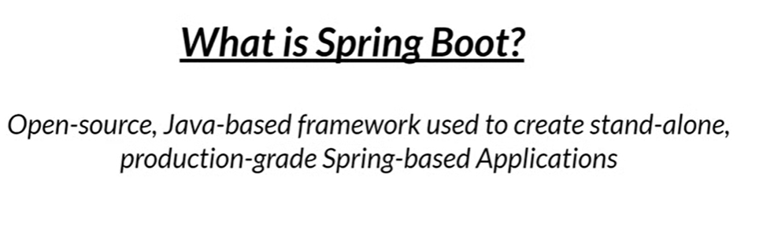
.
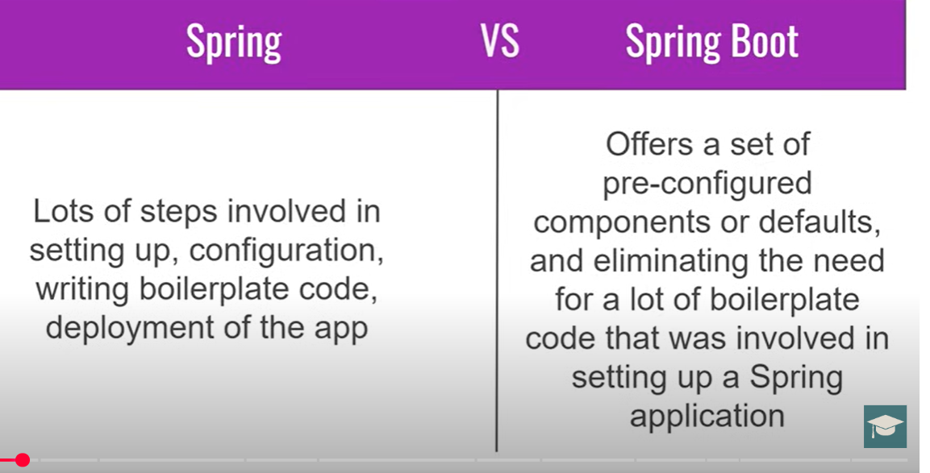
.
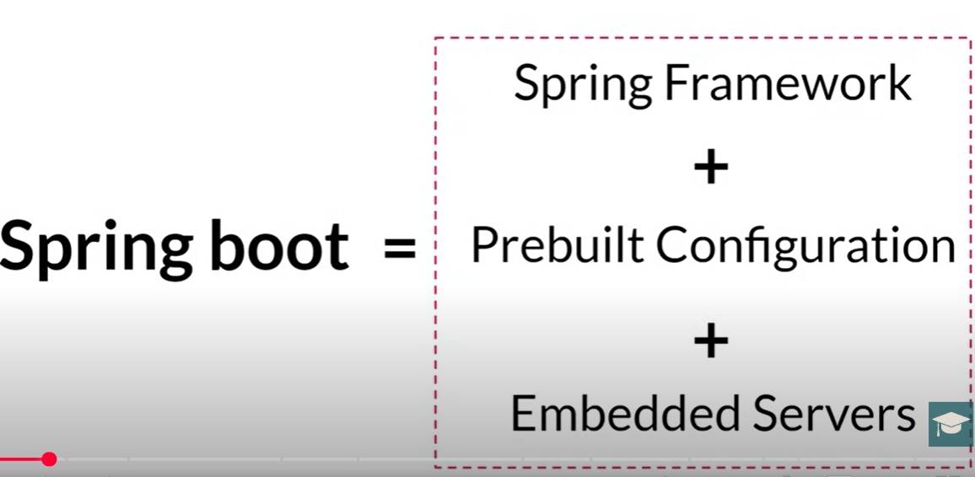
.
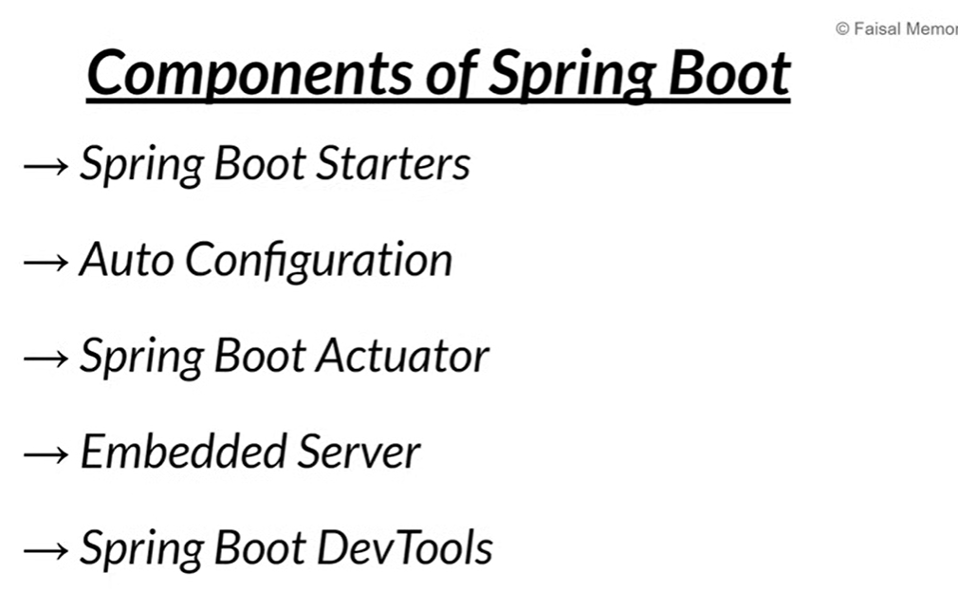
.

Components of Spring Boot
- Spring Boot Starters → Idhu oru ready-made dependencies bundle. Namaku venum nu sonna dependencies ah single line la add pannidum. Manual ah oru oru dependency add panna thevai illa.
- Auto Configuration → Spring Boot namma project la edhuku use pandrom nu detect panni, default settings la automatic ah configure pannidum.
- Spring Boot Actuator → Idhu application oda health, metrics, info, logs ellam monitor panna use aagum.
- Embedded Server → Spring Boot la inbuilt server (Tomcat, Jetty, Undertow) irukkum. Separate ah install panna thevai illa, project run pannum pothu server automatic start aagum.
- Spring Boot DevTools → Idhu developers ku fast development help pannum. Code la change pannumbothu application restart automatic ah nadakum, cache clear pannum.
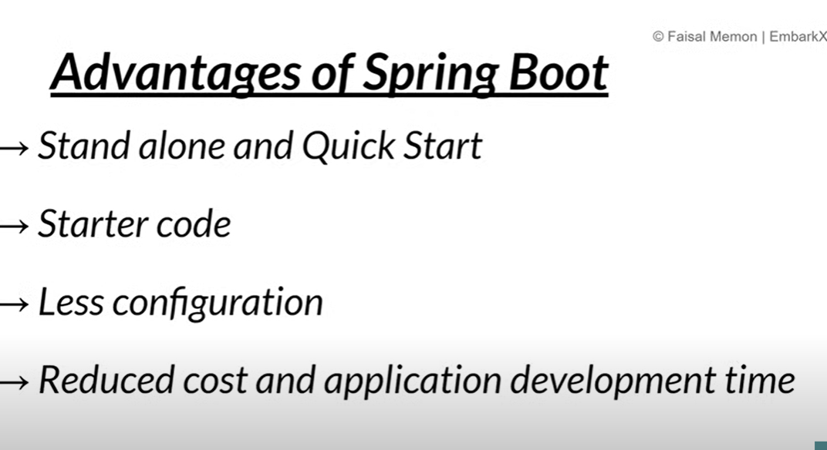
A standalone application is a self-contained program that can run independently without requiring any external server or additional software. In Spring Boot, applications are often standalone because they come with an embedded server like Tomcat or Jetty, allowing us to run them directly using java -jar without deploying to an external application server."
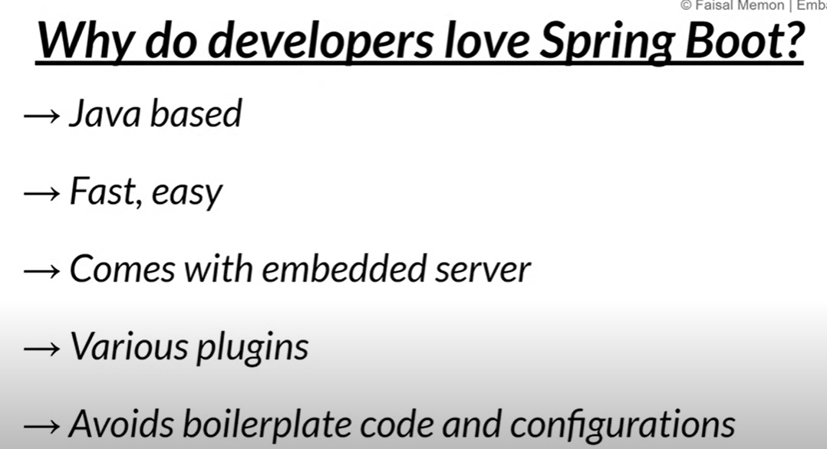
.
SpringBoot Architecture:
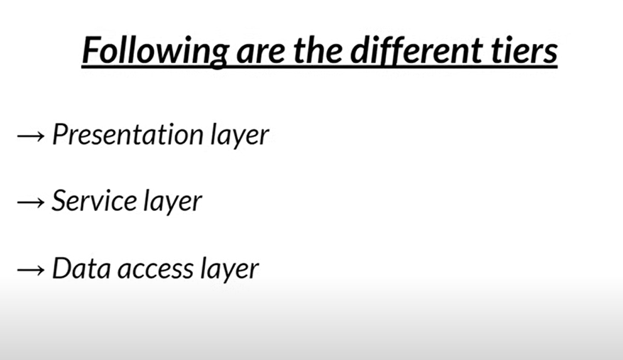
.
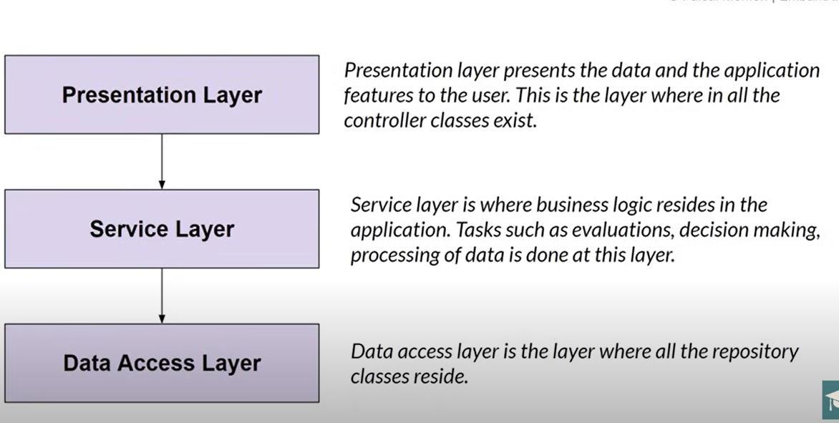
.
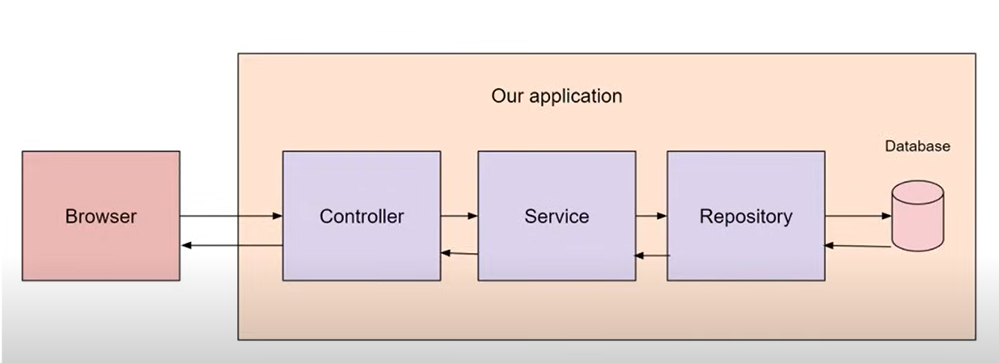
.

start.spring.io

→ Group name is nothing but package name .its usually reverse of domain name.
→ Artifact name is project name .
→ Dont use snapsot in the springboot version because its working on development .
→ Add Dependencies

Open In Intelij

POM.xml (Project Object Model)
- It is the main configuration file in a Maven project.
- Stores project details like name, version, and packaging type.
- Defines dependencies, so Maven can download required libraries automatically.
- Supports transitive dependencies (related libraries come automatically).
- Used to configure build plugins and project settings.
- In Spring Boot, we add starters in pom.xml to quickly include all needed dependencies for a module.
Example:
- Add spring-boot-starter-web → you get Spring MVC, Jackson (JSON), Validation, and an embedded Tomcat — all in one dependency line.
Maven Central – Key Points
- Main public repository for Java dependencies.
- Maven downloads jars from here if not found locally.
- Stores trusted, open-source libraries.
- Handles transitive dependencies automatically.
- Default repository for Maven projects.
Example:
Add in pom.xml:
<dependency>
<groupId>org.springframework.boot</groupId>
<artifactId>spring-boot-starter-web</artifactId>
</dependency>
Maven will fetch it from Maven Central:
🔗 https://search.maven.org/artifact/org.springframework.boot/spring-boot-starter-web

→ if you not find any some dependency.

DispatcherServlet enna?
- DispatcherServlet Spring MVC framework-oda core component.
- Adhu oru Front Controller pattern follow pannum.
- App-la varra ella HTTP request-um DispatcherServlet-kku varum first.
- Adhu appropriate controller (or endpoint) ku request-ai forward pannum.
- Response varachum, adhai client-kku return pannum.

Spring Boot-la DispatcherServlet role:
- Spring Boot-la automatically oru DispatcherServlet create aagum.
- Neenga manual-a create panna vendiyathu illai.
- Neenga controller classes (like @RestController or @Controller) create panna, DispatcherServlet avangalai handle pannum.
- Routing, view resolving, handler mapping ellaam DispatcherServlet manage pannum.

Simple analogy:
- DispatcherServlet = Traffic cop (traffic controller)
- Requests vandhuchu, "Ithu enga poganum?" nu paathu, correct controller-ku route pannum.

Summary in short:
DispatcherServlet in Spring Boot
Front Controller that handles all incoming HTTP requests.
Decides which controller to call based on URL mapping.
Manages the request processing workflow.
Auto-configured in Spring Boot; no manual setup needed.

Spring Boot: RestController, Controller, Serialization & Deserialization

1. @RestController
- Definition:
A specialized Spring annotation that combines @Controller and @ResponseBody.
It is used to build RESTful web services, where methods return data (usually JSON) directly in the HTTP response body.
- Key Points:
  - Automatically serializes returned Java objects to JSON or XML.
  - No need to add @ResponseBody on each method explicitly.
  - Simplifies REST API creation.
- Example:
java
CopyEdit
@RestController
public class HelloController {

@GetMapping("/hello")
public String sayHello() {
return "Hello World";
}
}

2. @Controller
- Definition:
The base annotation for Spring MVC controllers.
It is used to build web applications that return views (like JSP, Thymeleaf pages) instead of raw data.
- Key Points:
  - Methods usually return view names (template pages).
  - To send JSON data, you need to add @ResponseBody on methods or use @RestController.
- Example:
java
CopyEdit
@Controller
public class HomeController {

@GetMapping("/home")
public String homePage() {
return "home"; // returns view named "home"
}
}

3. @RequestBody
- Definition:
Annotation used in controller methods to bind the HTTP request body (usually JSON) to a Java object.
- Key Points:
  - Automatically deserializes JSON request payload into a Java object.
  - Useful in @RestController methods that accept POST, PUT, or PATCH requests with JSON data.
- Example:
java
CopyEdit
@PostMapping("/addUser")
public String addUser(@RequestBody User user) {
// 'user' object is populated from JSON sent in request body
return "User added successfully";
}

4. Serialization
- Definition:
Process of converting a Java object into a format (JSON/XML) for sending over the network or saving.
- In Spring Boot:
Spring Boot uses Jackson library by default to serialize objects returned by controller methods into JSON.

5. Deserialization
- Definition:
Process of converting JSON/XML data received from clients into Java objects.
- In Spring Boot:
When a controller method parameter is annotated with @RequestBody, Spring automatically deserializes the incoming JSON payload into the specified Java object.

6. Summary Table
Annotation/Term | Description | Example Use Case
@RestController | Controller that returns JSON/XML responses directly | REST API endpoints returning data
@Controller | Controller returning views/templates (e.g., JSP) | Web apps serving HTML pages
@RequestBody | Binds HTTP request body JSON to Java object | Receiving JSON payload in POST/PUT requests
Serialization | Java object → JSON/XML | Sending Java object as JSON response
Deserialization | JSON/XML → Java object | Reading JSON request body into Java object

2. Common Annotations to Get Data in Controller Methods
Annotation | What It Does | Example URL or Data
@RequestParam | Gets data from URL query parameters (?key=value) | /search?name=aravind
@PathVariable | Gets data from the URL path itself | /user/123
@RequestBody | Gets data from the body of POST/PUT request (usually JSON) | JSON payload in POST request body

3. Examples

Using @RequestParam
java
CopyEdit
@GetMapping("/search")
public String searchUser(@RequestParam String name) {
return "Searching user: " + name;
}
- URL: /search?name=aravind
- Here, name comes from the query parameter.

Using @PathVariable
java
CopyEdit
@GetMapping("/user/{id}")
public String getUserById(@PathVariable int id) {
return "User ID: " + id;
}
- URL: /user/123
- Here, id comes from the URL path.

Using @RequestBody
java
CopyEdit
@PostMapping("/user")
public String createUser(@RequestBody User user) {
return "Created user: " + user.getName();
}
- The client sends JSON in the request body:
json
CopyEdit
{
"name": "Aravind",
"age": 25
}
- The JSON is converted to a Java User object.

4. Summary Table
Annotation | Source of Data | Usage Example
@RequestParam | URL query parameters | /search?name=aravind
@PathVariable | URL path segments | /user/123
@RequestBody | HTTP request body | POST JSON payload with user info

Spring Boot Auto-Configuration (Simple & Detailed Explanation)

What is Auto-Configuration?
- Auto-Configuration is a feature in Spring Boot that automatically sets up the necessary configurations and beans for your application based on the libraries (dependencies) you include in your project.
- It saves you from writing lots of repetitive and manual configuration.

How does it work?
- When your Spring Boot app starts, it looks at the classpath (the libraries you have added).
- Based on what it finds, it applies default configurations automatically.
- For example:
  - If you have spring-boot-starter-web, it sets up a web server, DispatcherServlet, and MVC components automatically.
  - If you have spring-boot-starter-data-jpa, it configures your DataSource, EntityManager, and JPA repositories.

How does Spring Boot know what to configure?
- Spring Boot uses a special file called spring.factories located inside its JAR files.
- This file lists many Auto-Configuration classes inside the package org.springframework.boot.autoconfigure.
- These classes contain the configuration code.
- Spring Boot loads these classes conditionally — meaning it only activates them if certain classes or beans are present.

How do you enable Auto-Configuration?
- By default, when you use @SpringBootApplication, it includes the annotation @EnableAutoConfiguration which enables this feature automatically.
- So usually, you don’t need to do anything extra!

Can you customize or disable Auto-Configuration?
- Yes!
- You can exclude specific auto-configuration classes if you want to disable some default setup. For example:
java
CopyEdit
@SpringBootApplication(exclude = {DataSourceAutoConfiguration.class})
public class MyApplication {
public static void main(String[] args) {
SpringApplication.run(MyApplication.class, args);
}
}
- You can also override auto-configured beans by defining your own beans with the same name or type.
- You can configure properties in application.properties or application.yml to customize behavior.

Why is Auto-Configuration useful?
- It reduces boilerplate code and speeds up development.
- You get sensible defaults without writing configs manually.
- You can start coding business logic immediately without worrying about setup.
- It still allows flexibility because you can override or disable configs as needed.

Some common Auto-Configuration examples
Dependency | What Spring Boot auto-configures
spring-boot-starter-web | Embedded Tomcat, DispatcherServlet, Spring MVC
spring-boot-starter-data-jpa | DataSource, EntityManagerFactory, JPA repositories
spring-boot-starter-security | Spring Security filters and default login page
spring-boot-starter-thymeleaf | Thymeleaf view resolver and template engine

Summary
Feature | Description
Auto-Configuration | Automatically configures your app based on dependencies and classpath
Enabled by | @EnableAutoConfiguration (part of @SpringBootApplication)
Config classes | Located in org.springframework.boot.autoconfigure and loaded via spring.factories
Customization | Exclude via exclude attribute, override beans, or configure with properties
Benefits | Saves time, reduces boilerplate, provides sensible defaults, but still customizable

Application Properties

What is application.properties in Spring Boot?
application.properties is a file where you write settings for your Spring Boot app. It tells your app things like:
- Which port to run on (like 8080 or 9090)
- How to connect to your database (URL, username, password)
- Logging levels (to see more or less info in logs)
- Other custom settings for your app

Where do you keep this file?
You put it inside your project at:

src/main/resources/application.properties
Spring Boot will automatically read this file when the app starts.

Why is it useful?
Because you can change how your app works without changing the code. Just update this file and restart the app.

Can you give an example?

server.port=8081
spring.datasource.url=jdbc:mysql://localhost:3306/mydb
spring.datasource.username=root
spring.datasource.password=secret
logging.level.org.springframework=DEBUG
This means:
- Run the app on port 8081
- Connect to MySQL database at localhost:3306/mydb with user root and password secret
- Show debug logs for Spring framework classes

What if I want different settings for dev and production?
You can create files like:
- application-dev.properties (for development)
- application-prod.properties (for production)
And tell Spring Boot which one to use with profiles.

How does Spring Boot use this file?
Spring Boot reads application.properties automatically at startup and applies the settings. If you give settings in other places (like command line), those can override this file.

Quick answers to common interview questions:
- Q: What is application.properties?
A: It’s a file to configure your Spring Boot app settings.
- Q: Where is it located?
A: In src/main/resources folder.
- Q: What kind of settings go here?
A: Server ports, database configs, logging, and other custom app settings.
- Q: How do you handle different environments?
A: Use profiles with different property files like application-dev.properties.

PROJECT
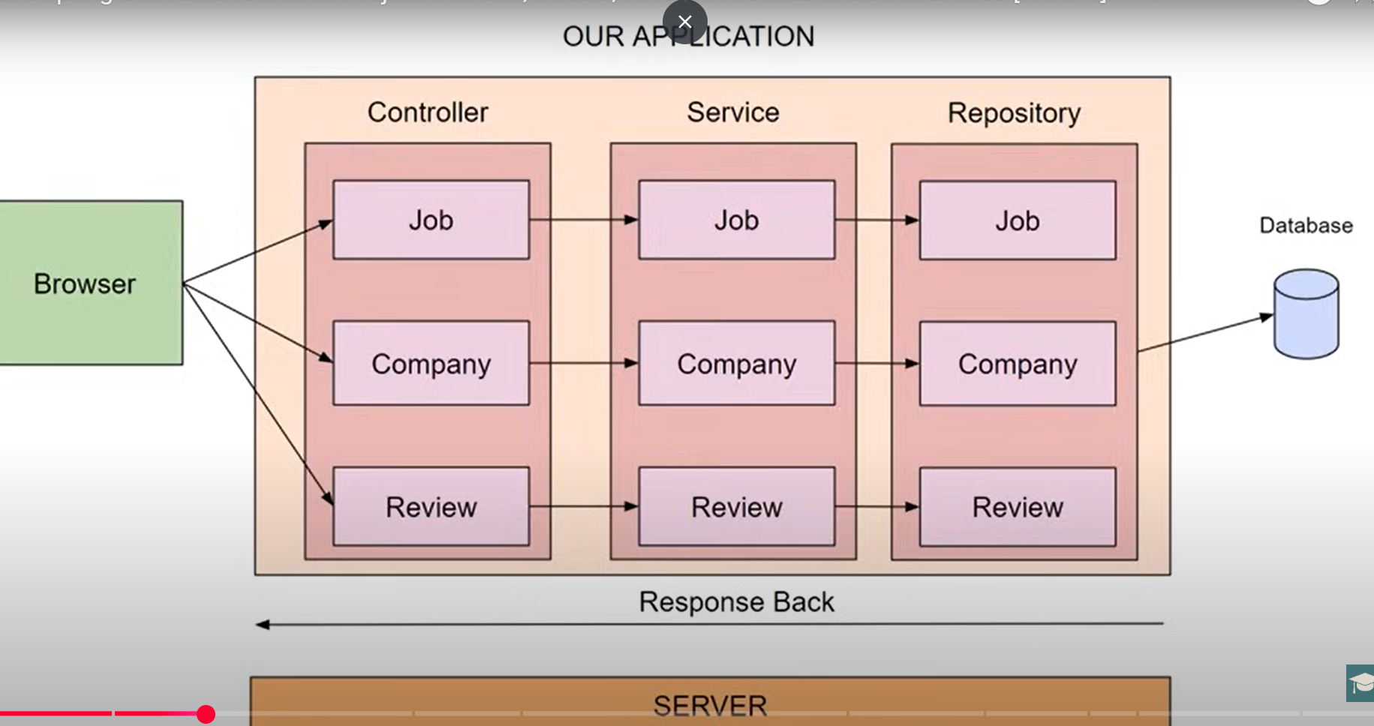

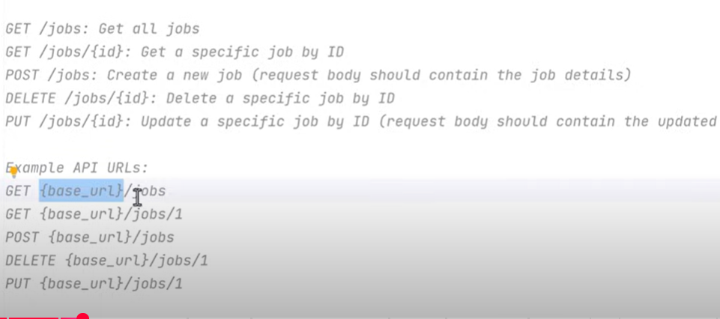
Task for Job controller

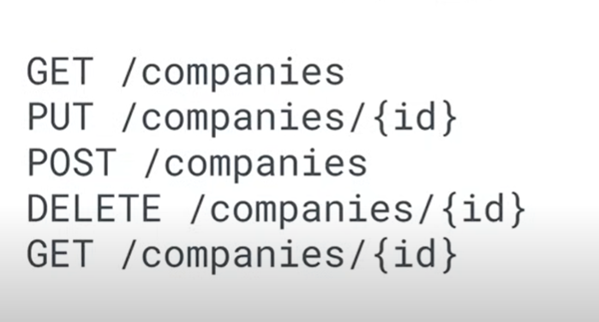
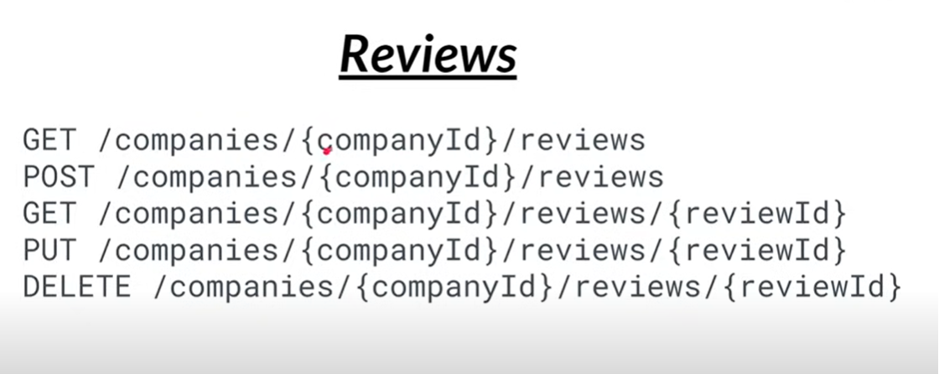
..

📌 Simple Notes — @RequestMapping in Spring Boot

What it does
- Maps HTTP requests (URL + method type) to specific controller methods.
- Can be applied at class level and method level.
- Class level → base URL for all methods inside.
- Method level → specific endpoint under that base URL.

Example

Class level + Method level together

@Controller
@RequestMapping("/api") // base URL
public class MyController {

@RequestMapping("/hello") // final URL: /api/hello
public String sayHello() {
return "hello";
}
}
- Class level /api
- Method level /hello
- Final URL = /api/hello

HTTP Method Specific

@RequestMapping(value = "/hello", method = RequestMethod.GET)
public String getHello() {
return "hello";
}
- Old way of specifying GET, POST, etc.
- Now we often use:
  - @GetMapping (for GET)
  - @PostMapping (for POST)
  - @PutMapping, @DeleteMapping, etc.

📌 ResponseEntity — Quick Notes
- Purpose: Full control over HTTP status + headers + body.
- Without ResponseEntity: Always returns body with default status 200.
- With ResponseEntity: Can set:
  - Status → ResponseEntity.status(HttpStatus.OK)
  - Headers → .header("Key", "Value")
  - Body → .body(data)

Common Methods
Method | What it does
ok(body) | 200 OK + body
status(HttpStatus.X) | Custom status
noContent() | 204 No Content
badRequest() | 400 Bad Request
notFound() | 404 Not Found

📌 fetch Response Object
From backend → frontend:
- response.status → status code (200, 404, 500…)
- response.ok → true if 200–299
- response.headers.get("Header-Name") → read header
- response.json() → read JSON body
- response.text() → read plain text body

2. Common Usage in Controller

a) Simple OK response

@GetMapping("/hello")
public ResponseEntity<String> hello() {
return ResponseEntity.ok("Hello, World!");
}
- Status → 200 OK
- Body → "Hello, World!"

b) Custom Status

@GetMapping("/error")
public ResponseEntity<String> errorExample() {
return ResponseEntity.status(HttpStatus.INTERNAL_SERVER_ERROR)
.body("Something went wrong!");
}
- Status → 500 Internal Server Error
- Body → "Something went wrong!"

c) With Headers

@GetMapping("/with-header")
public ResponseEntity<String> withHeader() {
return ResponseEntity.ok()
.header("Custom-Header", "MyValue")
.body("Header added");
}
- Adds Custom-Header: MyValue in HTTP response

d) No Content
@DeleteMapping("/delete/{id}")
public ResponseEntity<Void> deleteUser(@PathVariable int id) {
// delete logic
return ResponseEntity.noContent().build();
}
- Status → 204 No Content
- No body

e) JSON Object

@GetMapping("/user")
public ResponseEntity<User> getUser() {
User user = new User("Aravind", "aravind@example.com");
return ResponseEntity.ok(user); // auto converts to JSON
}
- Body → JSON object
- Status → 200 OK


